VEX IQ Level Up: Session 1

Activity: Drive and try to score with Virtual Driving Skills Practice.

You will drive the Hero Bot, Flop, around a virtual version of the VEX IQ Level Up Field in Virtual Driving Skills Practice.
- The joysticks on the Controller drive Flop around the field, based on the Drive Mode selected.
- The right and left sets of buttons control the Arm and Intake motors.
- Huey starts with a yellow preloaded Bean Bag in its Intake.
You score points by placing Bean Bags in goals.
Each Yellow Bean Bag or matching-colored Red or Blue Bean Bag in a floor goal is worth 1 point.  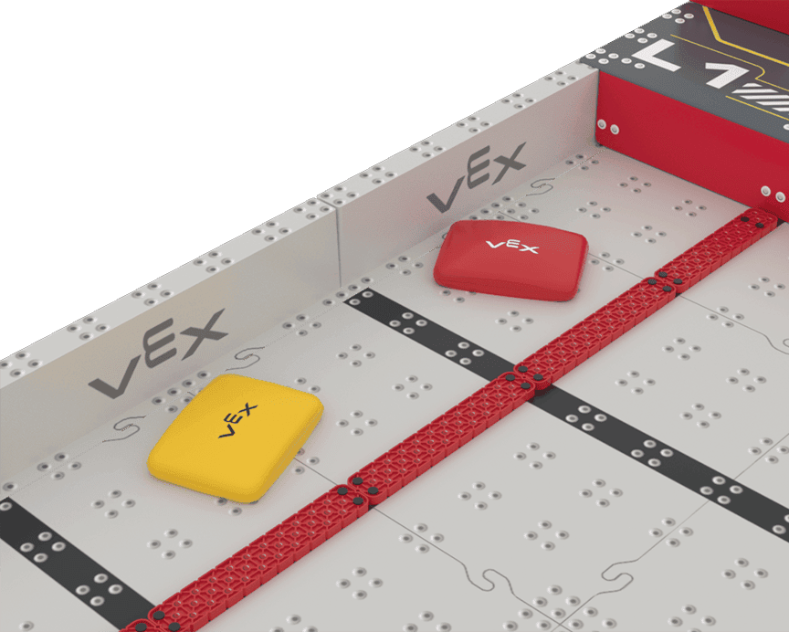 |  | Each Yellow Bean Bag or matching-colored Red or Blue Bean Bag is worth a different number of points depending on the Level:  - L1 Goal - 3 Points  - L2 Goal - 6 Points  - L3 Goal - 12 Points  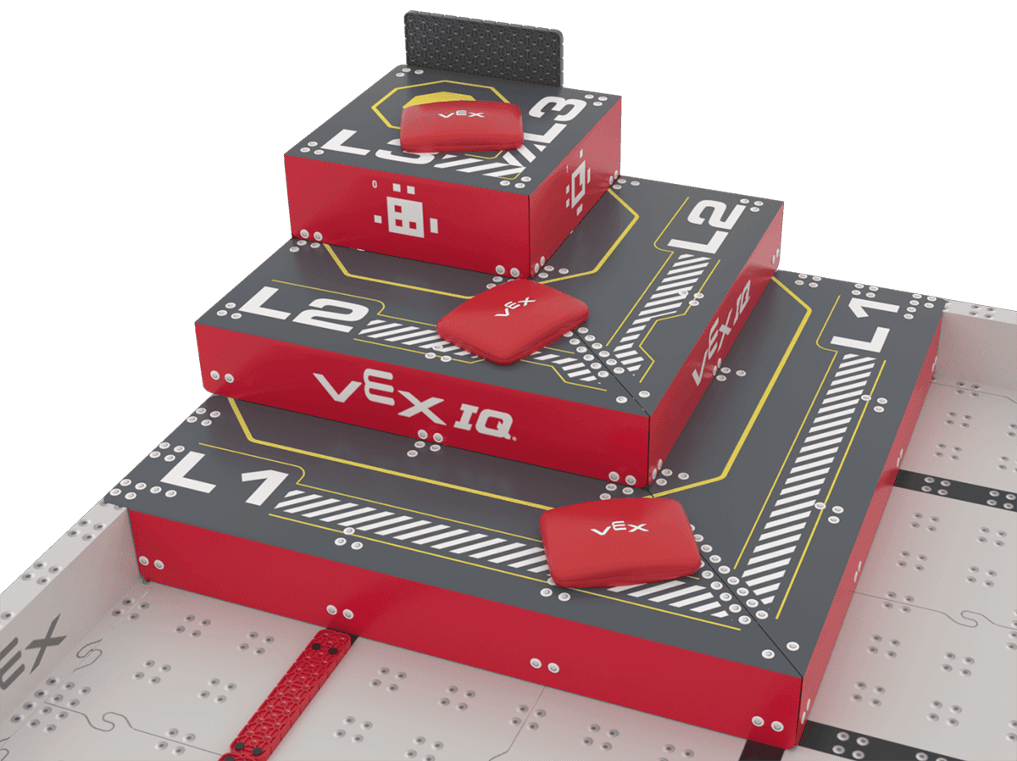 |  | 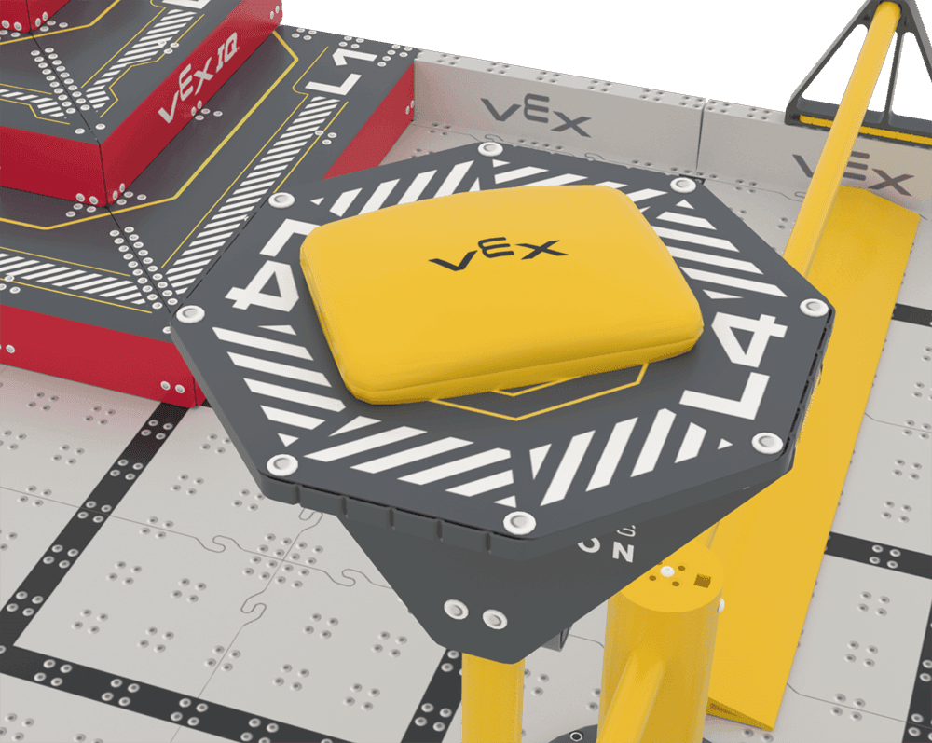  Each Yellow Bean Bag scored on an L4 Goal is worth 16 points.

- Open VEX IQ Level Up Virtual Driving Skills Practice.
  - Get your Team Number and Virtual Skills Key from your Coach to access the game.
- Choose one or more of the following to try when it is your turn to drive:
- Score a Bean Bag in a Floor Goal
- Score a Bean Bag on each of the levels of the Pyramid Goal
- Score a Yellow Bean Bag on the L4 Goal

Remember, each team member will have at least one turn to drive.
Feeling Stuck?
Remember, the default Drive Mode is Tank Drive. That means each motor is controlled by a joystick.

Discussion Questions
- Is driving Flop easier or harder than you thought it would be? Why?
- What is one pro-tip you would give to a teammate?
- What is one thing you want to practice more based on your turn?

